/* Ashok

Extract, Transformation and Load Basics Lab

6.13.19 */

1… text file to sql table

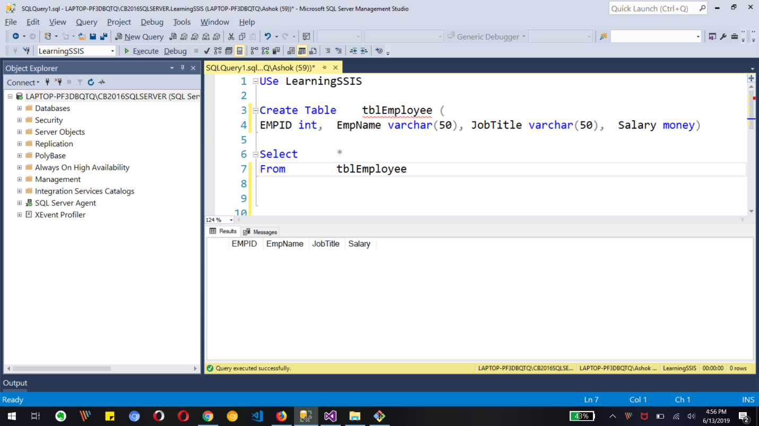

Create table in Database

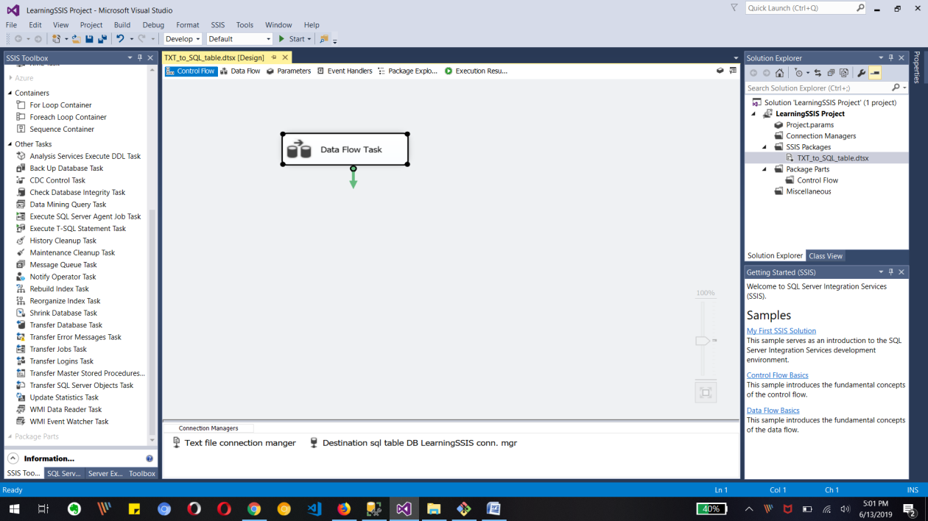Adding DATA flow task to created SSIS project

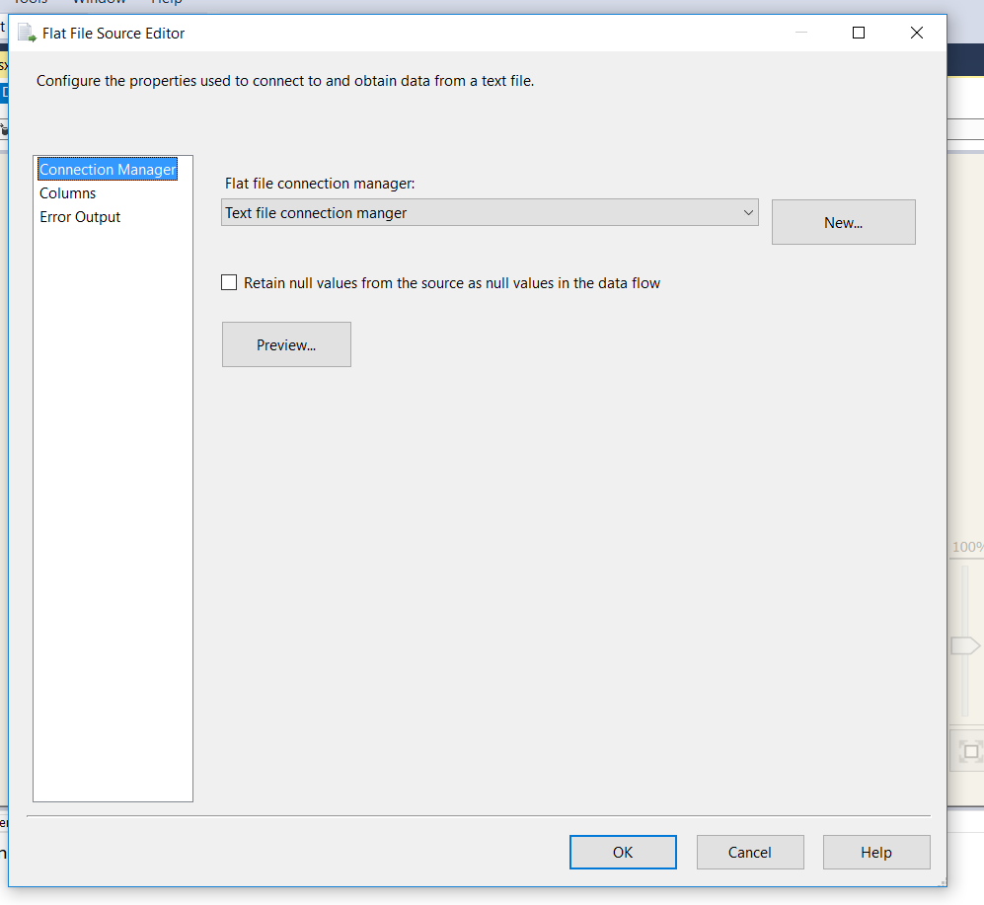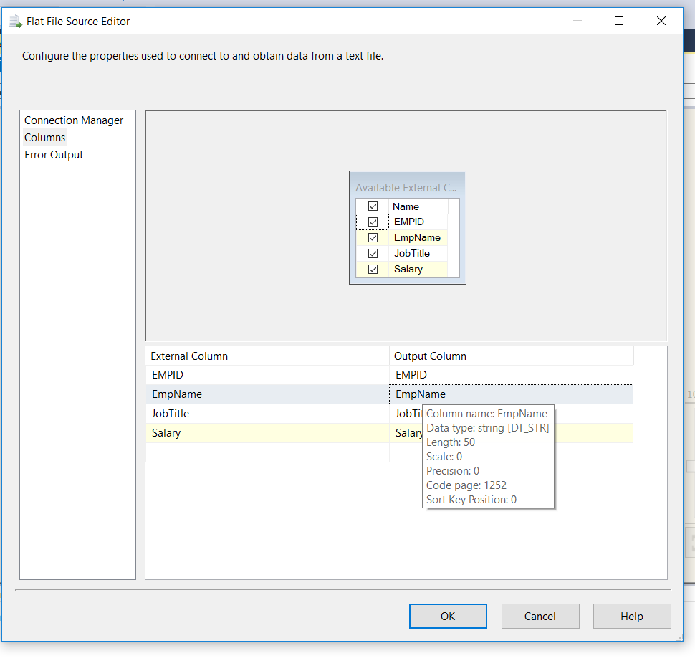

Connection for text/flat file source and columns of text file

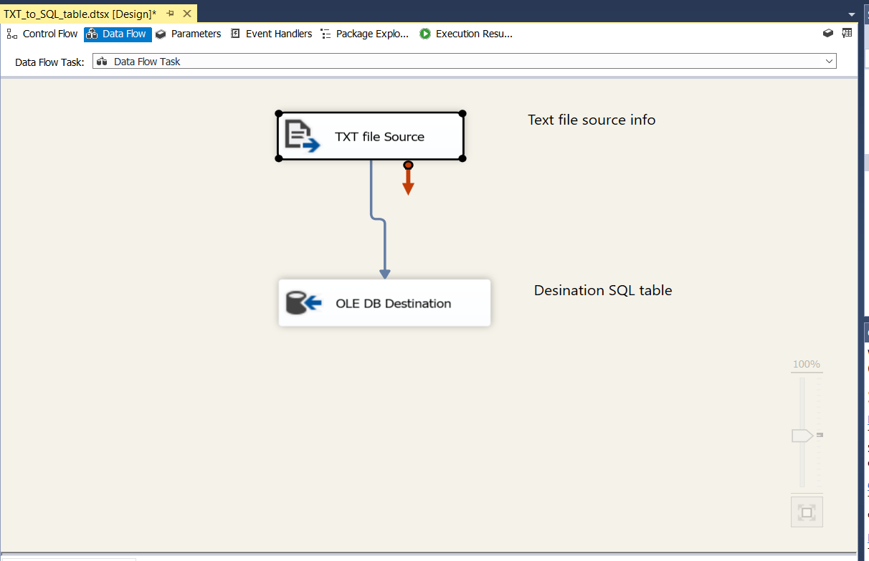

Above image shows Text file source and OLE db destination tasks

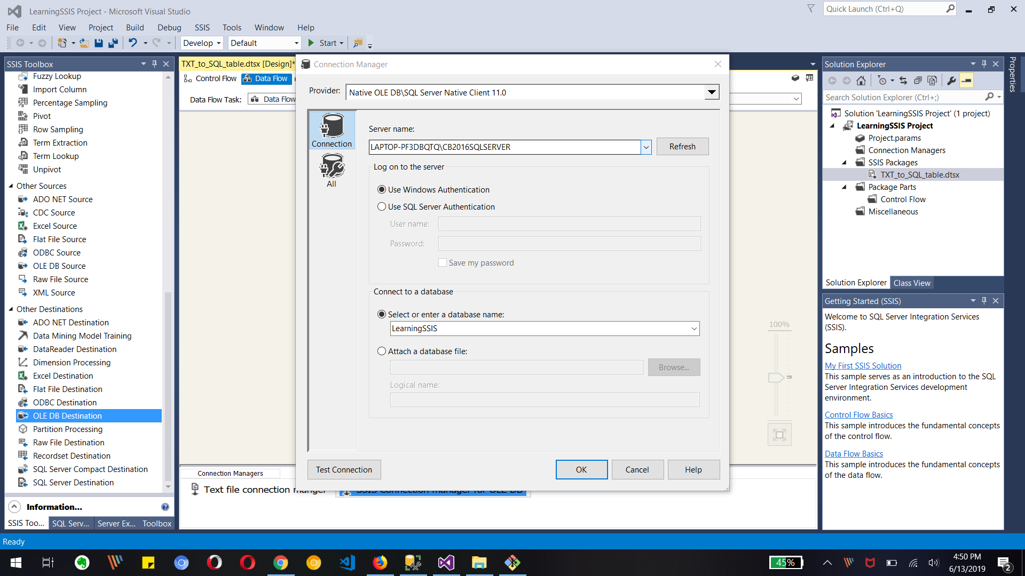

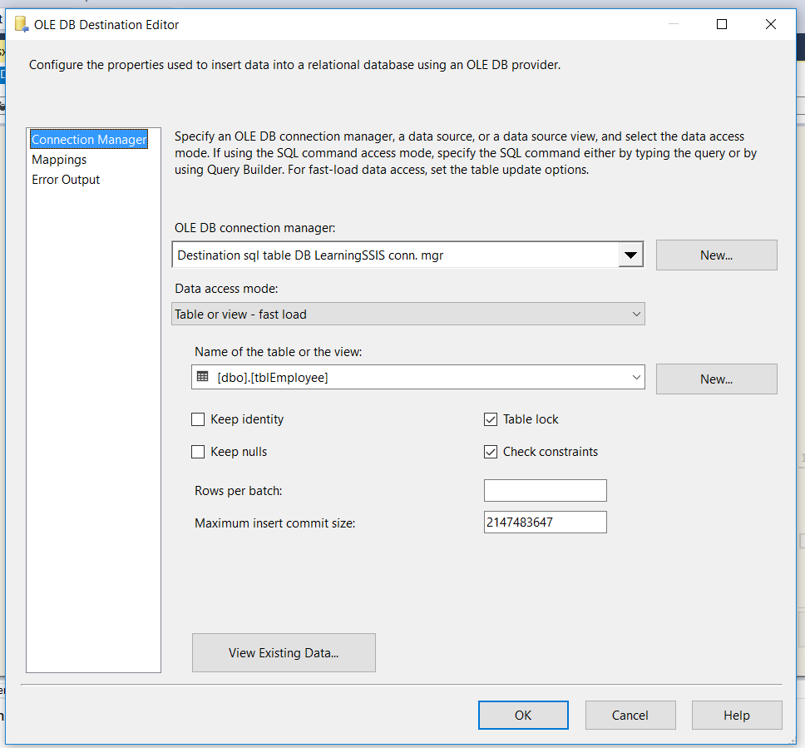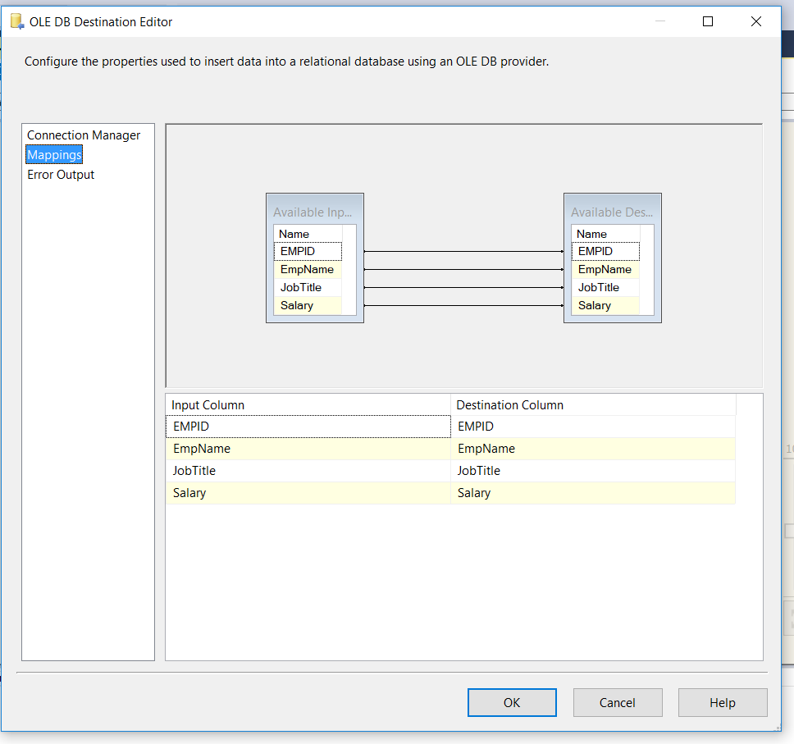

Creating connection manage for OLEDB, and adding employee table to destination editor.

Also Mapping text file columns to destination table columns

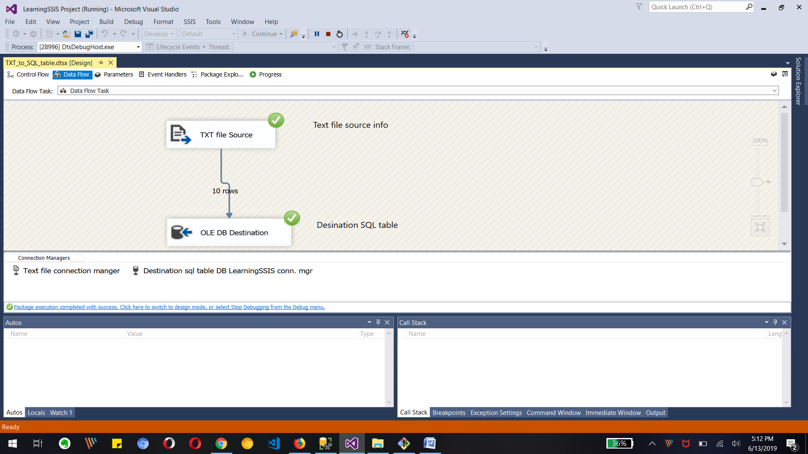

Final Output as 10 rows transferred to sql table

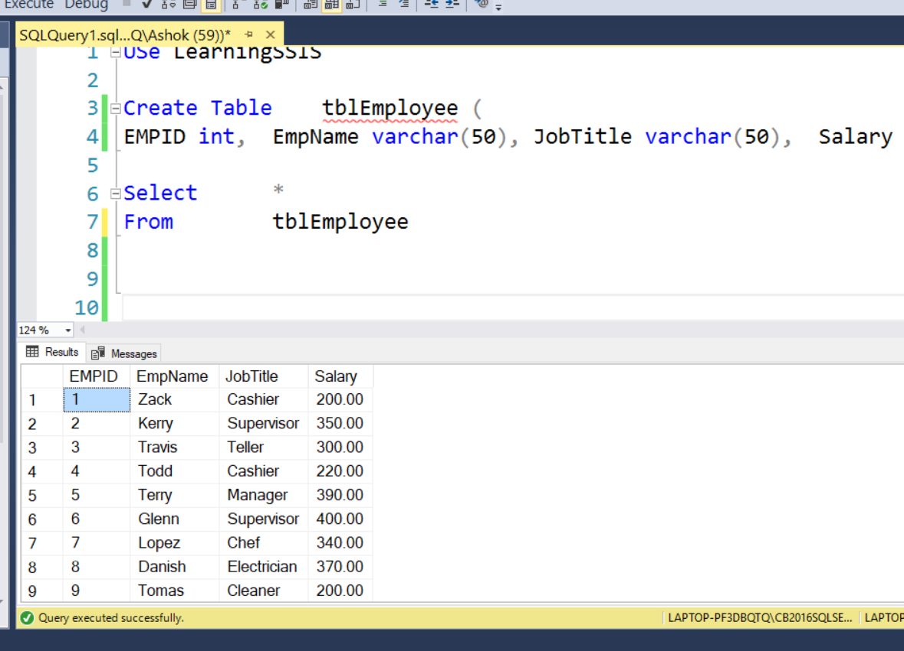  
Final output in SQL manager for table

2. Create table tblEmp in LearningSIS2 database with the same schema as

LearningSSIS..tblEmployee table

3. (do not populate tblEmp)

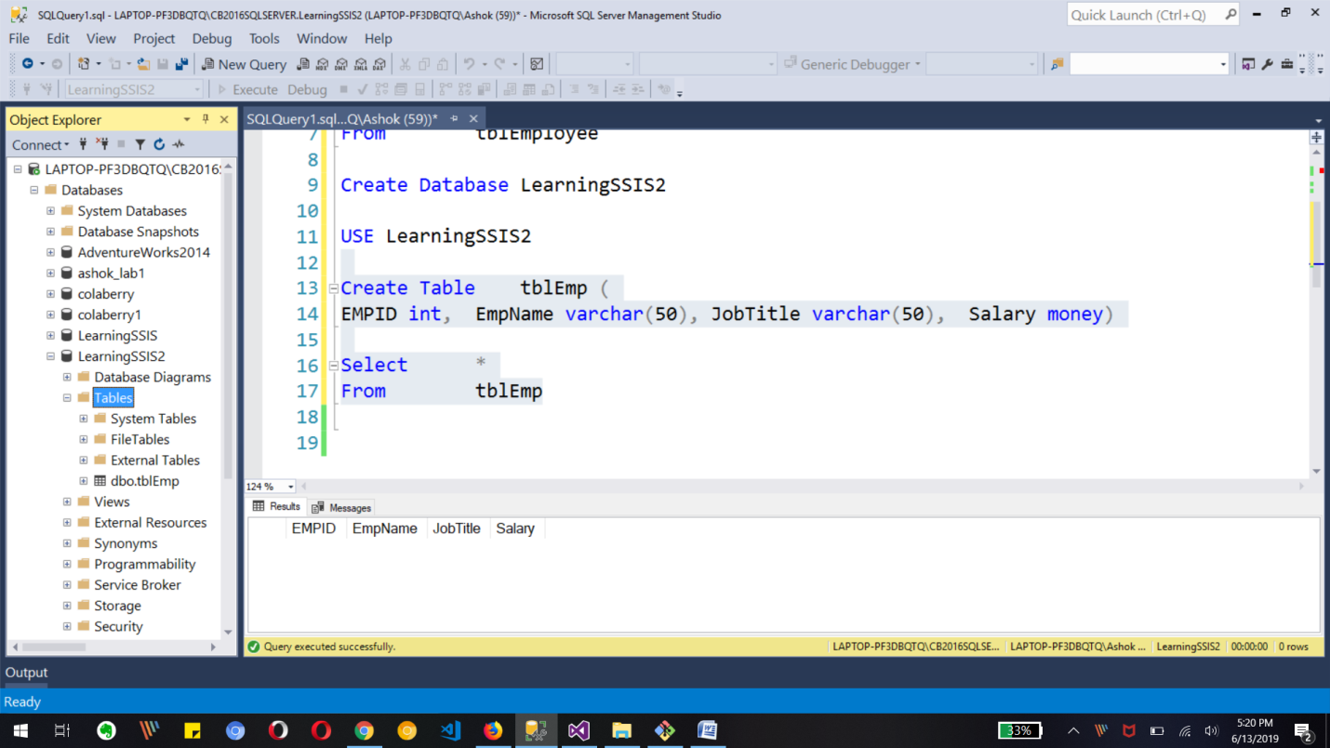

4. Create a SSIS package to load the data from LearningSSIS..tblEmployee to

LearningSSIS2..tblEmp

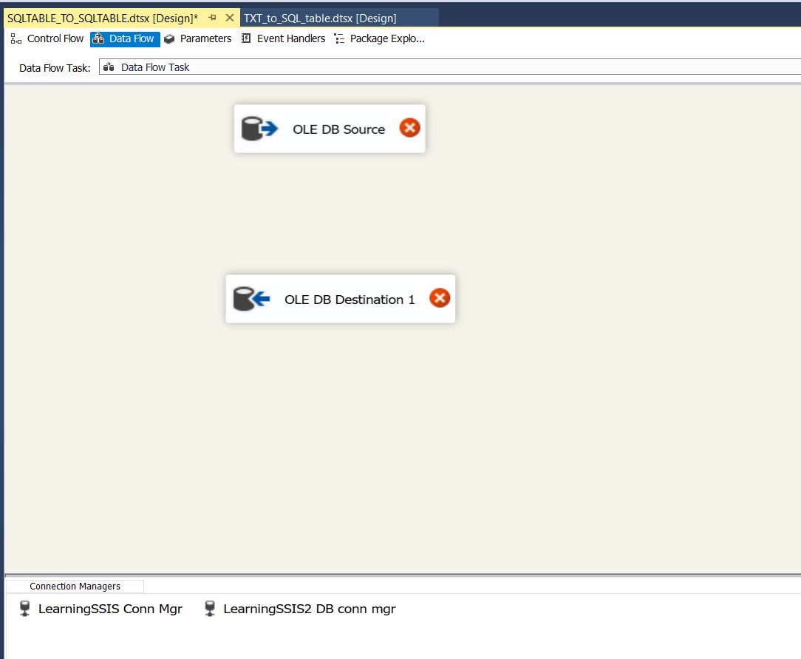Creating OleDB source and destination task inside data flow task

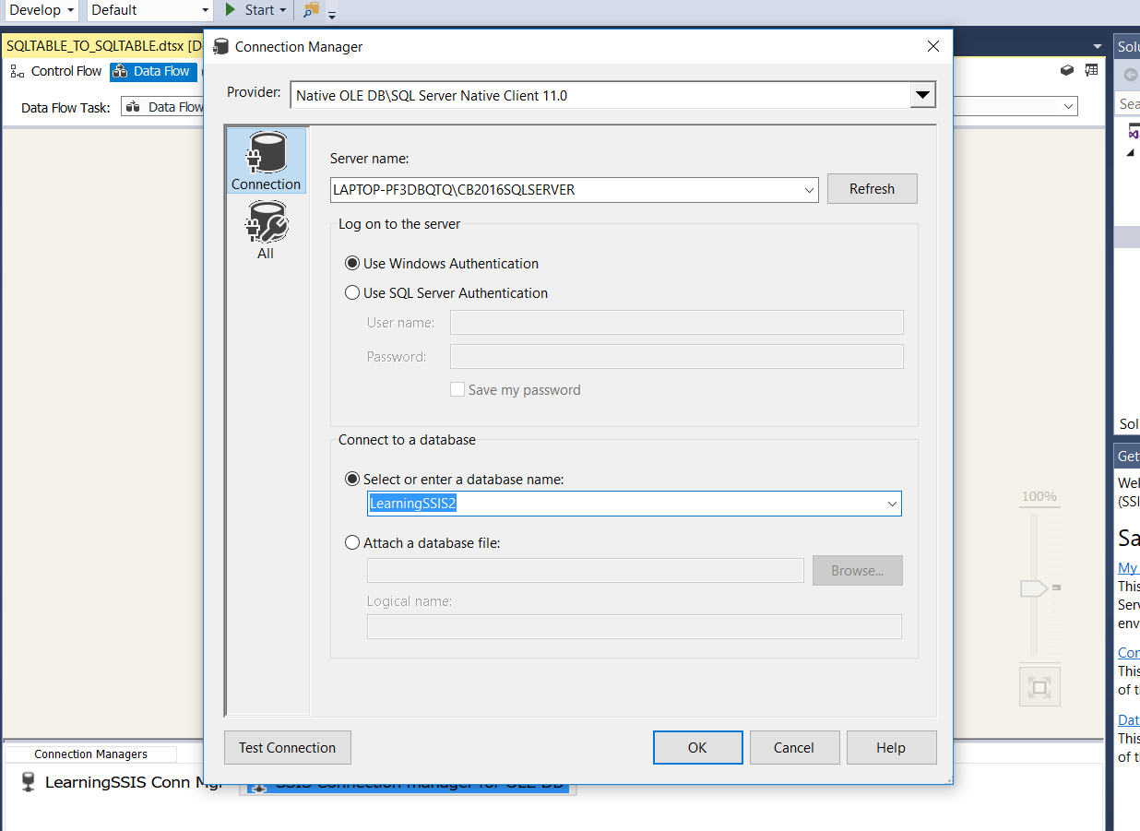

Creating new connection manager for LearningSSIS2 database

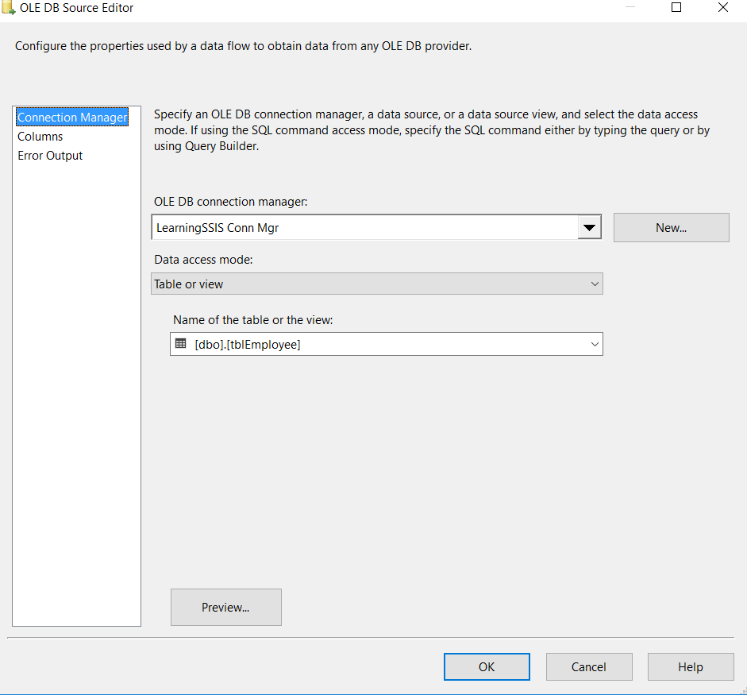 

Creating connection for source and destination OLE DB

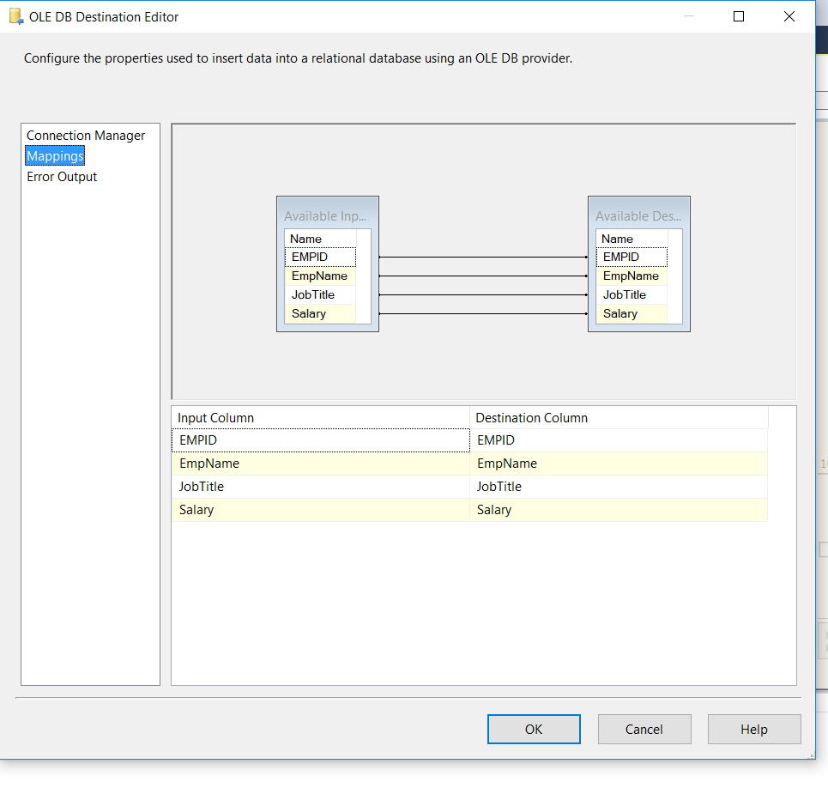

Mapping columns to columns in Destination connection Manager

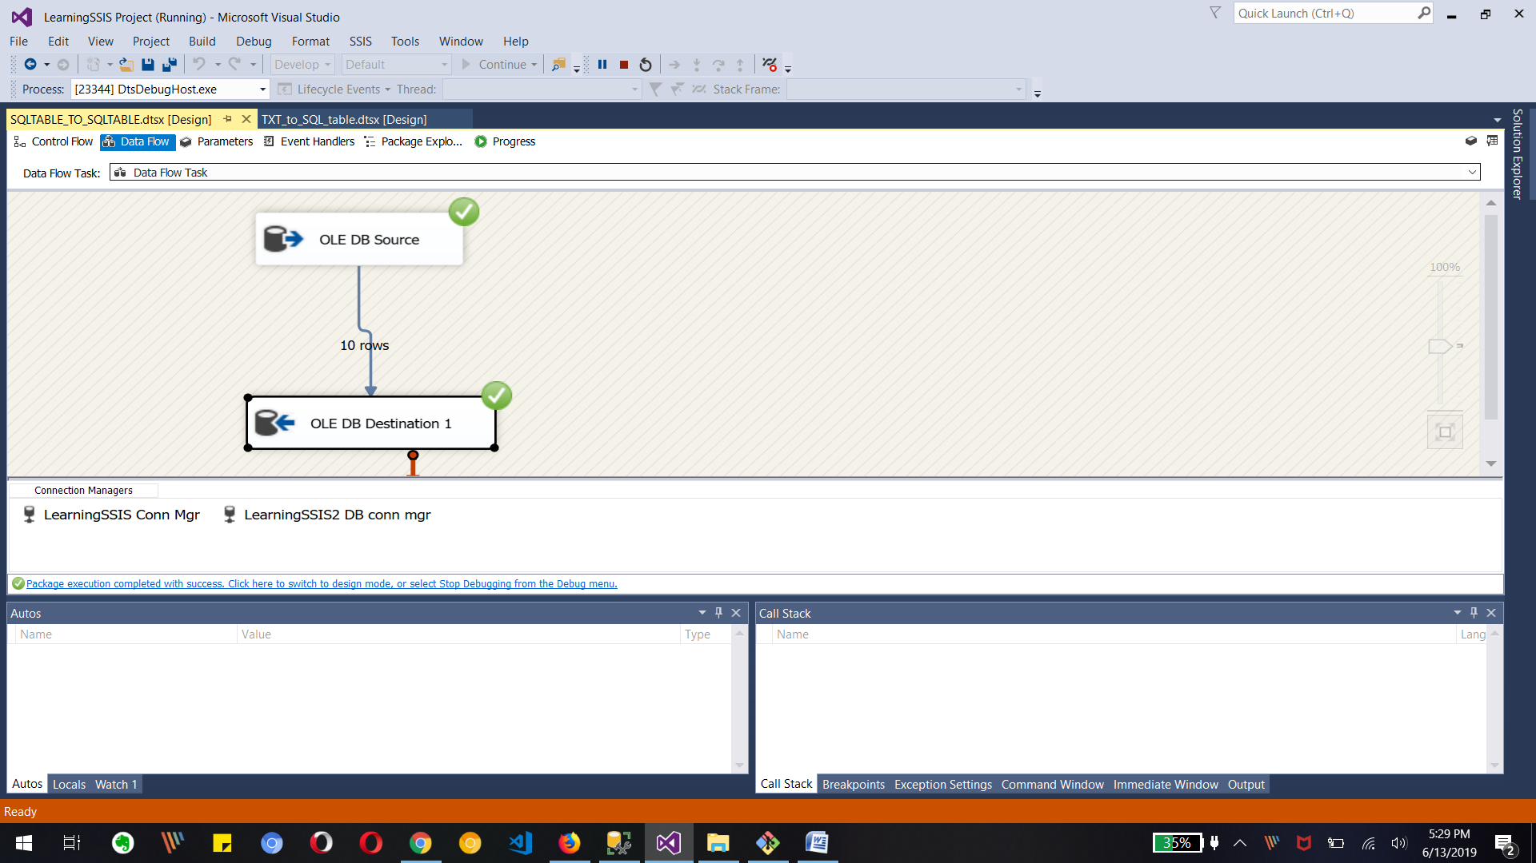

Running package and it shows 10 rows transferred.

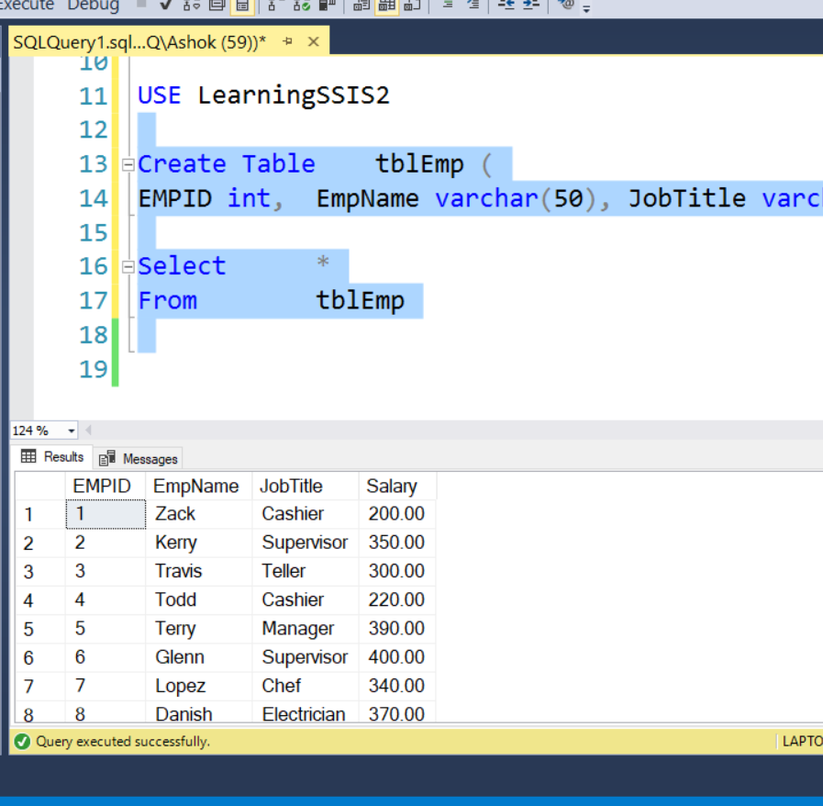

Final output in SSMS for tblEmp table in learningSSIS2 database

5. Create database Prospects

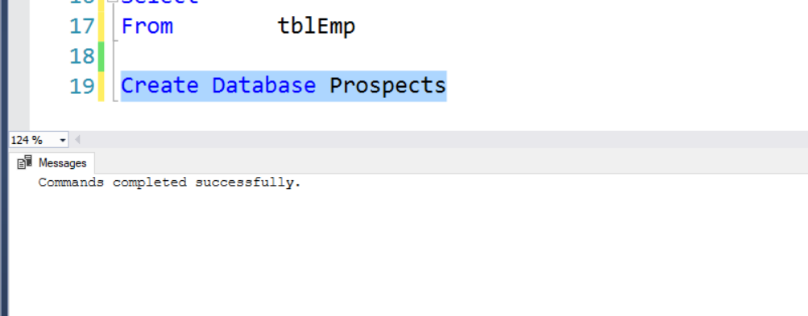

6. Create table tbl_stg_Prospects in Prospects – (Refer to Project document)

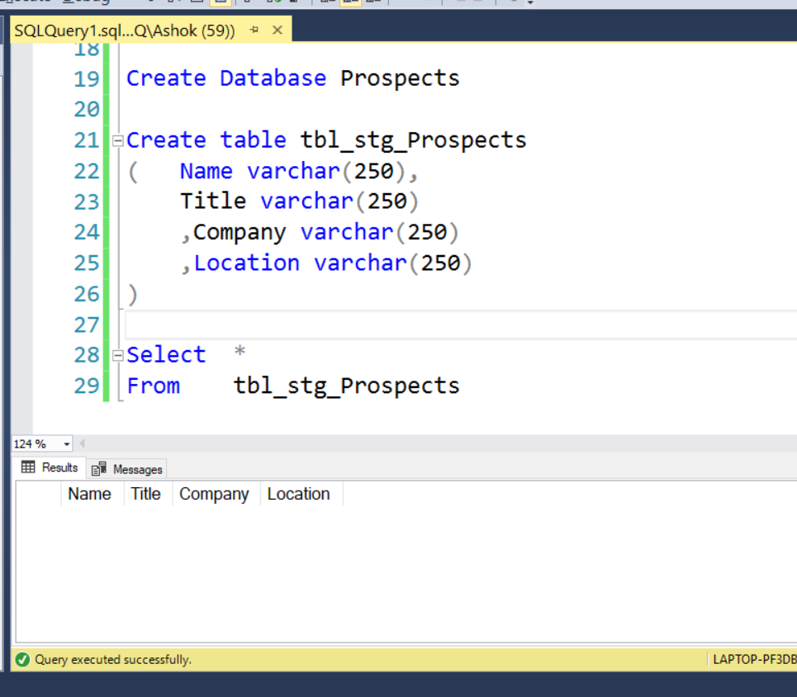

7. Create a SSIS package Load_Prospects_Staging.dtsx to load the data from Prospect_B.xls to

tbl_stg_Prospect



Creating database and Prospects table as mentioned above

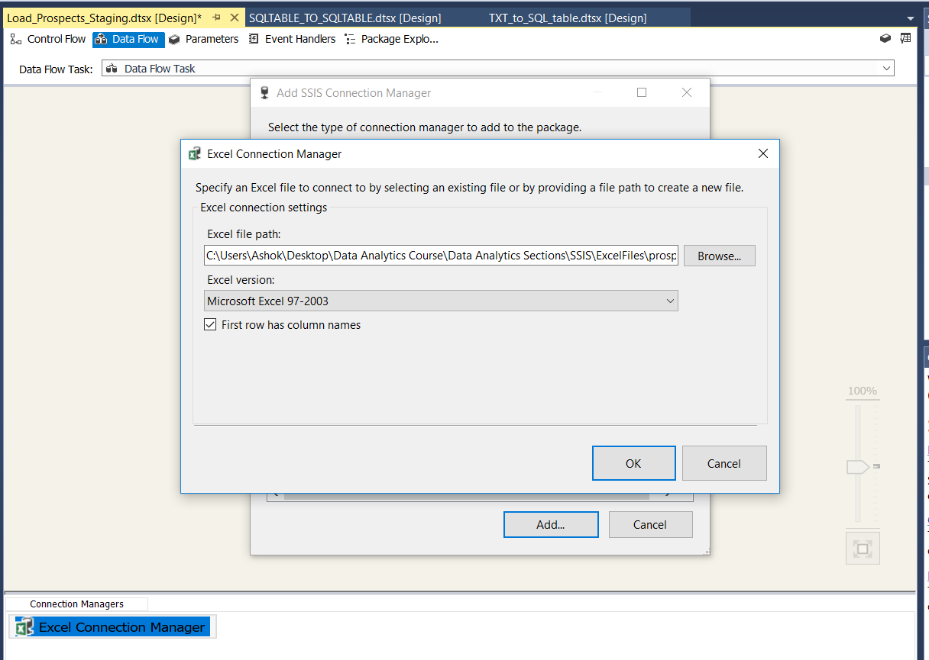Creating connection manager for Excel source

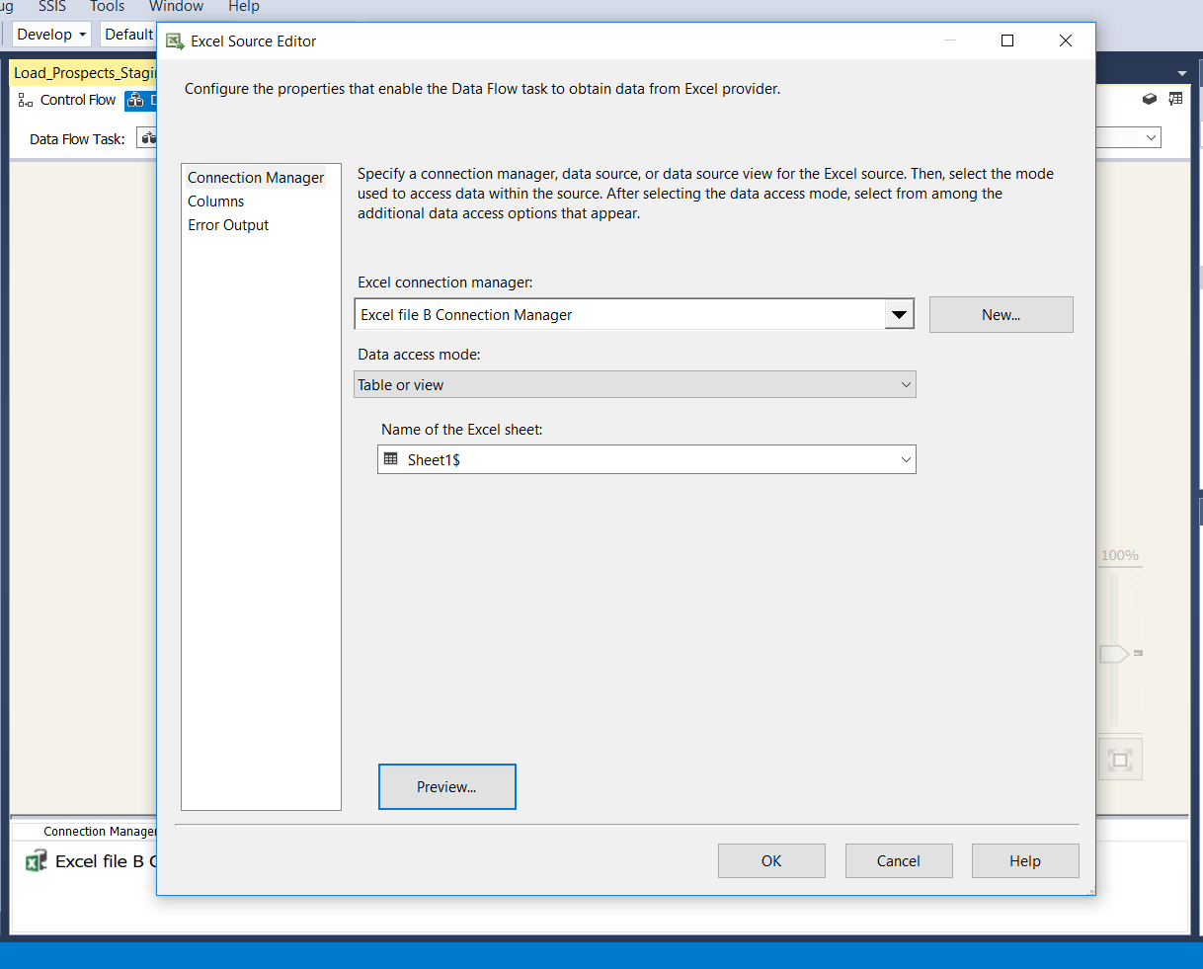

Section of excel file connection and it sheet number for data

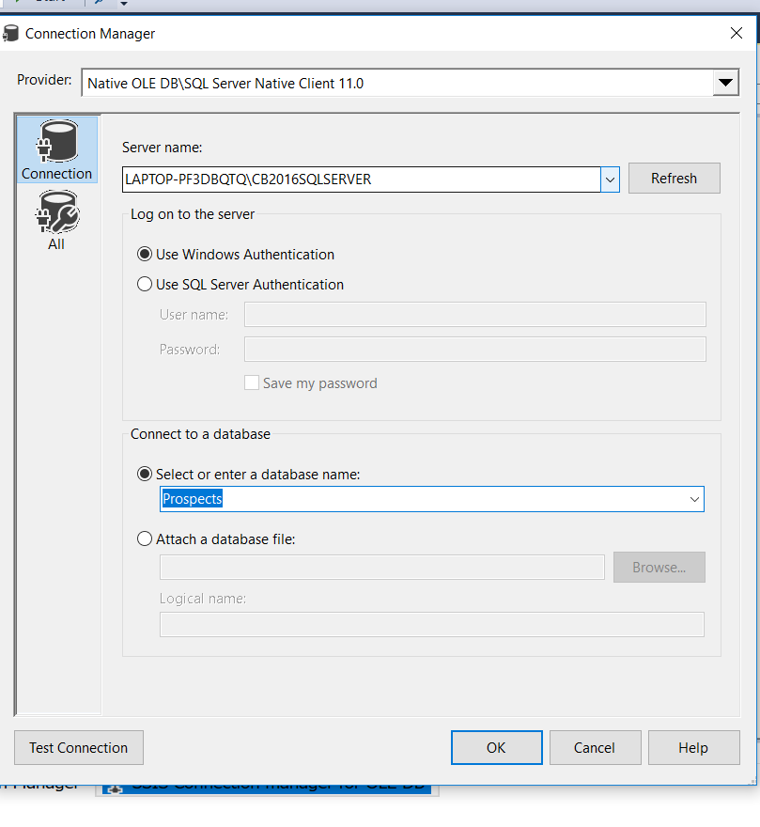

Creating Connection manager for OLE DB destination sql table

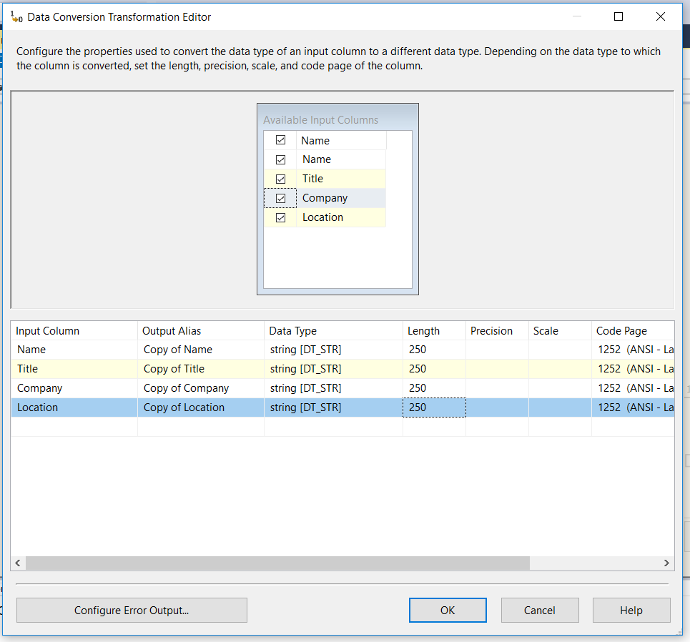

Data conversion is needed for Excel file so doing that in conversion transformation editor

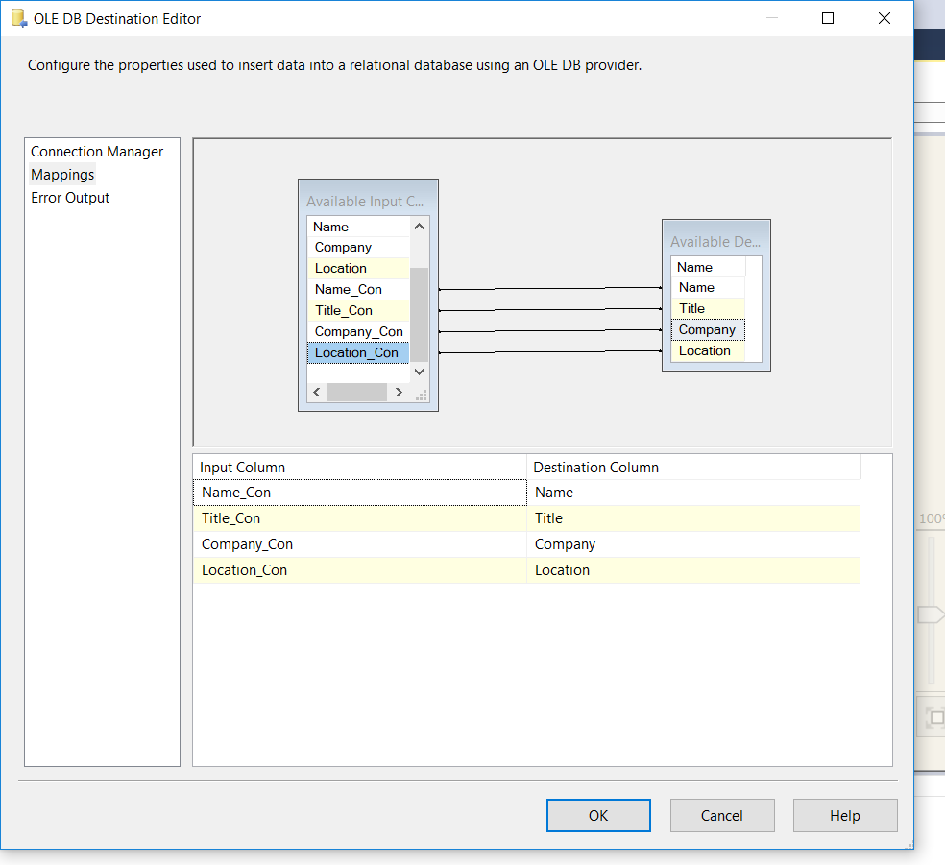Mapping the right columns to SQL table columns in destination connection manager

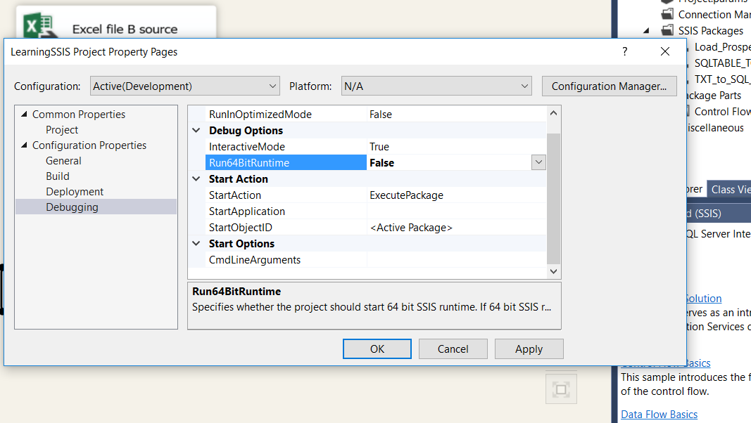

Need to update run64bit Runtime for Project as we have Excel file

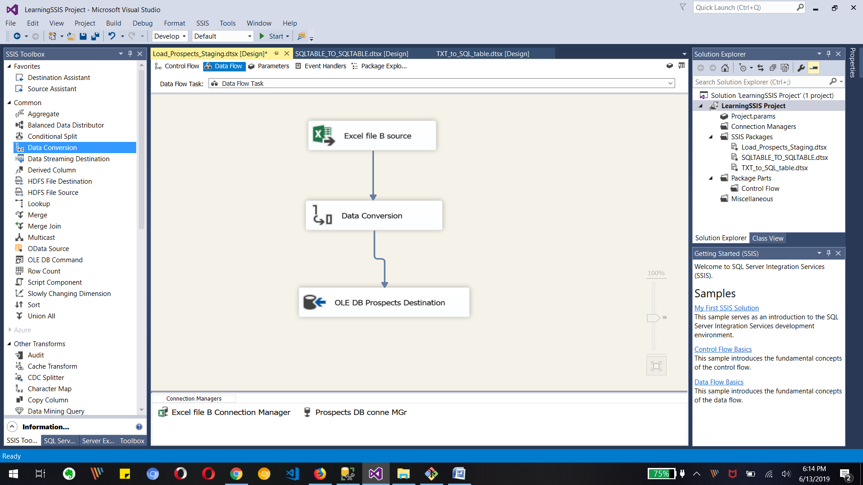

Final look of Project for Excel to SQL table data transfer

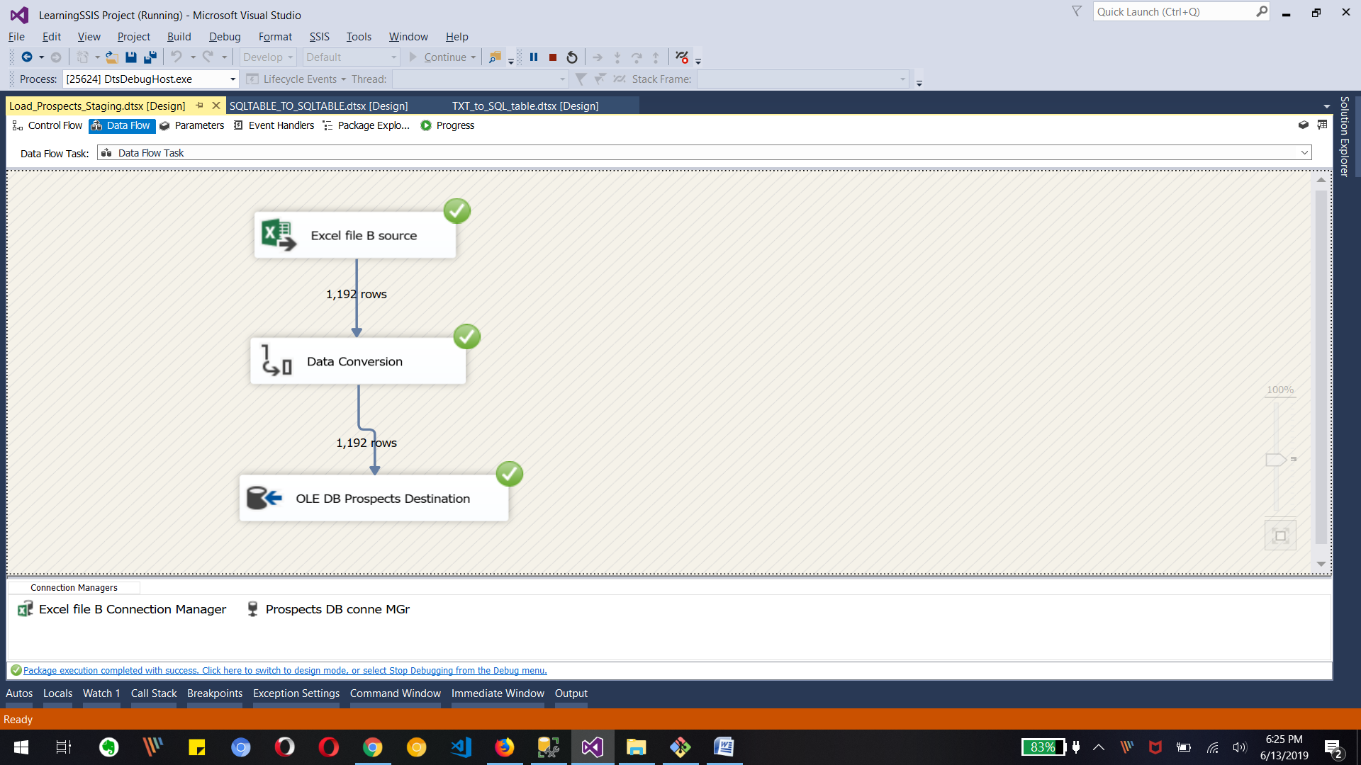

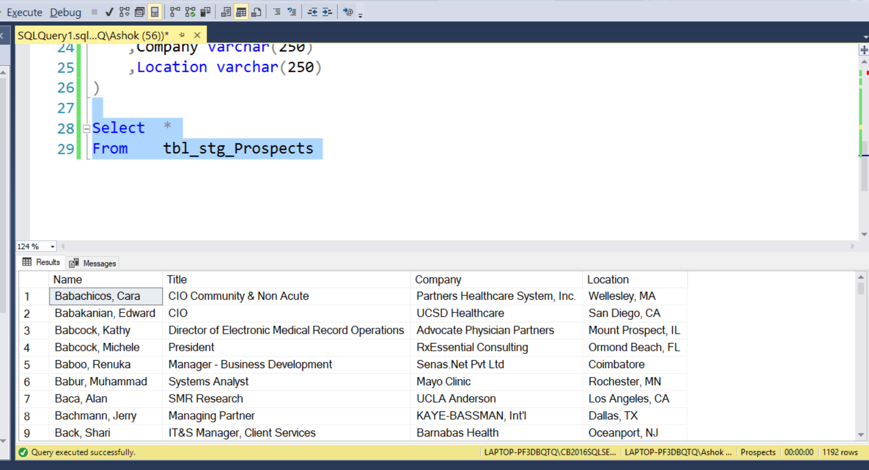

Final Output for 1192 rows transferred to Sql Table

**Importance of ETL in Organization Article in Group discussion.**

